# Inspecting a Docker Image with Docker-diff:

Following is a sample dockerfile:

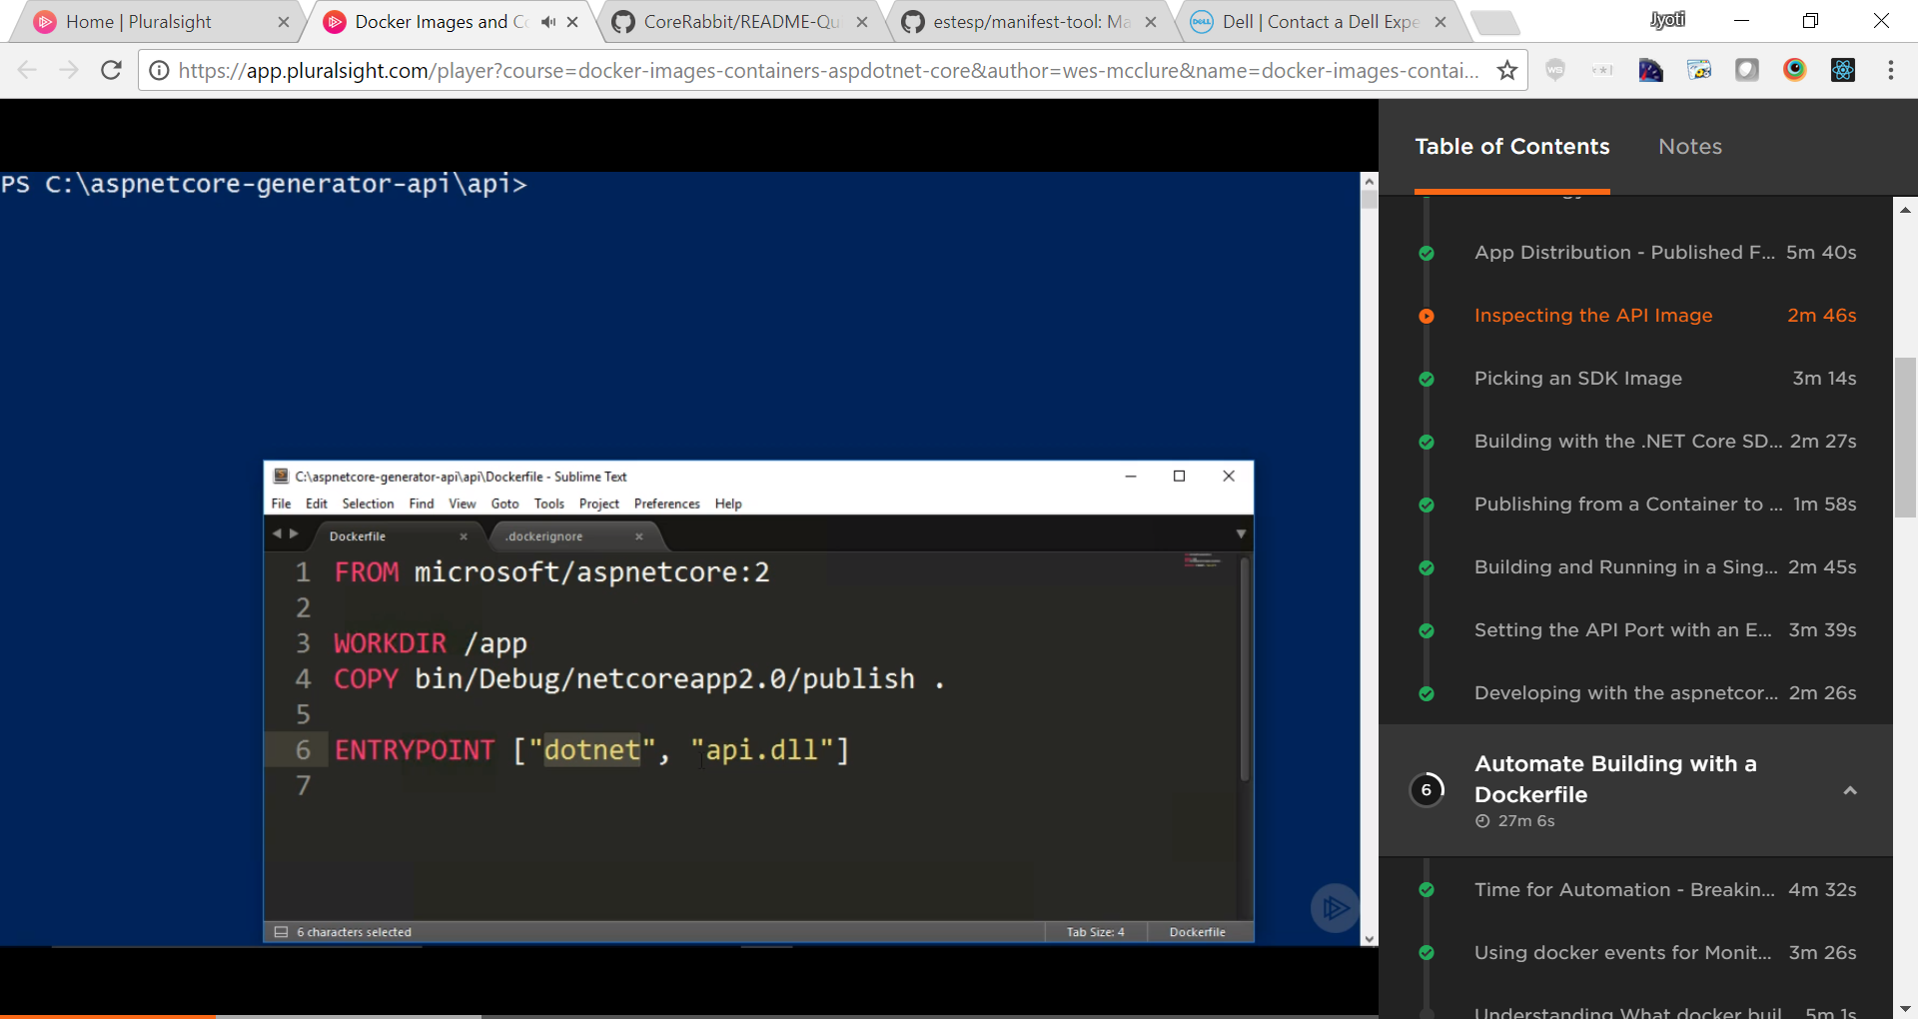

By default, docker creates intermediate containers per instruction in dockerfile.

To see what happens in each intermediary step, let’s change the command like following (highlighted *docker build* command line):

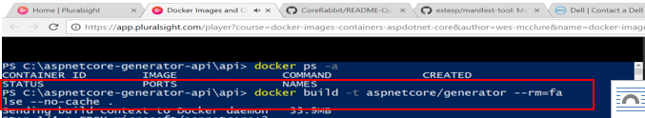

It won’t delete the intermediate containers anymore:

That can be verified by following screenshot where intermediate containers are being created but not deleted:

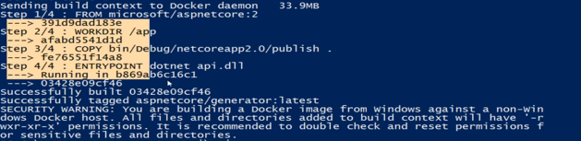

You can see all the intermediate containers listed in *Docker PS* command now:

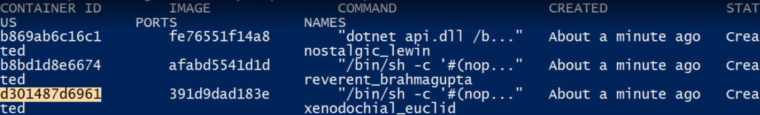

Containers are listed in descending order of their create date. So, the first intermediary container created will be listed at bottom and final container is listed on top.

**Docker Diff**: to see the changes in each version of intermediary container, use docker diff command.

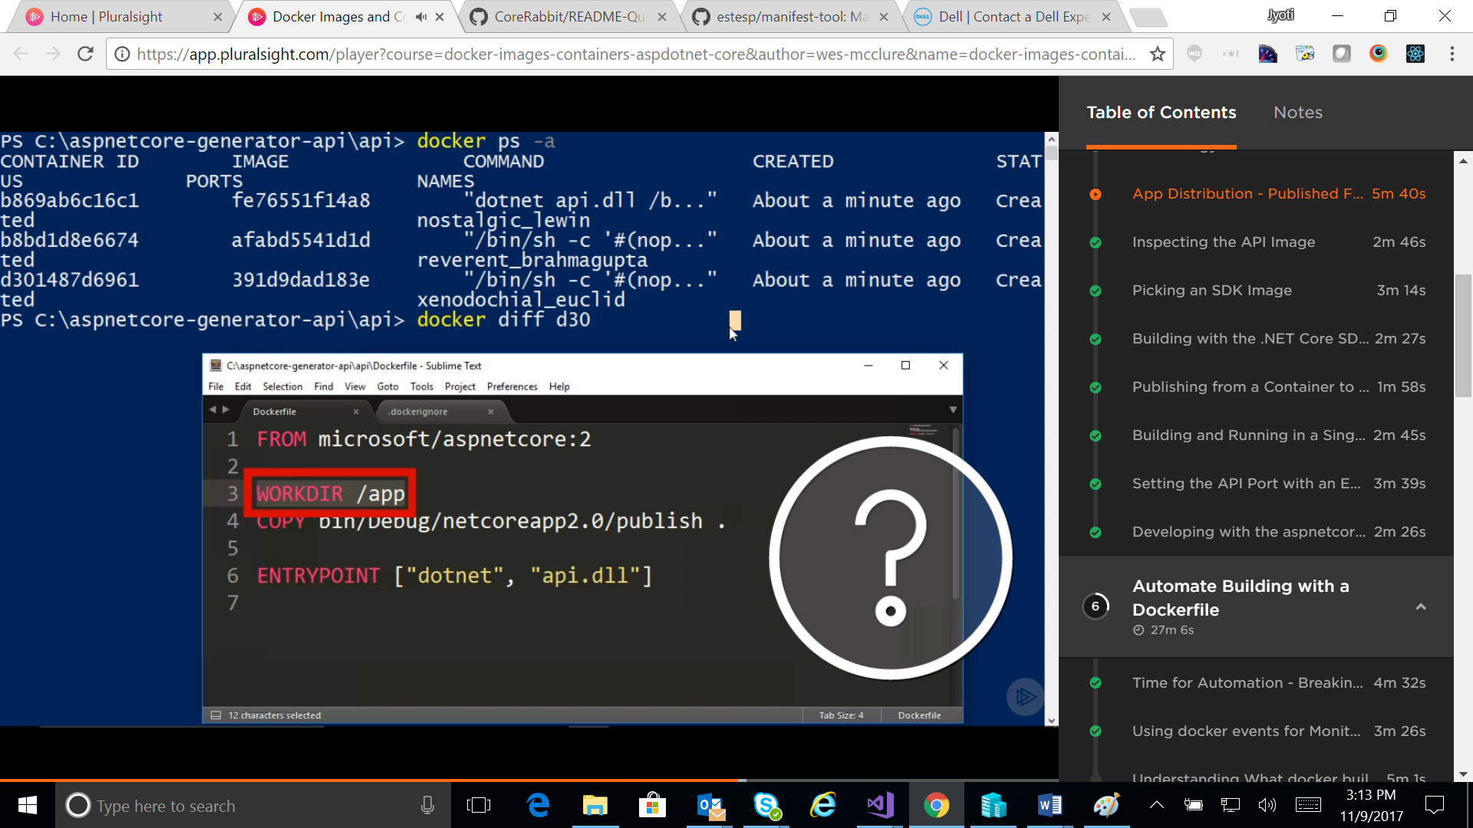

It should show as following:



Let’s use diff for next intermediary container:

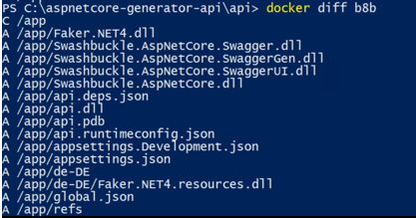

It shows all the files copied as diff result.

# Monitoring Docker using Docker Events:

Open 2 docker cli. One to fire the docker commands and second one to monitor the docker eventing.

In second CLI, use Docker event command as following:



--format ensures the format of events are published, in the above case it’s JSON format. *Jq* piping does the color coding of output.

In CLI1, now, run a simple docker command…



The Docker engine events shall be displayed in events CLI. In this example, in side-by-side window, it should show as following:

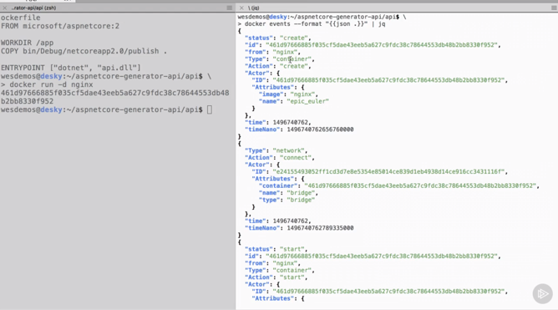

## How to know execution Timeline of Docker command:

First run a docker command as following:

Use Get-History command along with $command as following:

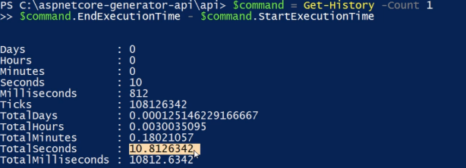

## Docker Container Restart option:

Docker container can be started with an option to restart at a port with multiple options namely: always, no, on-failure, unless-stopped



## Setting the Environment variables using Docker run:

An environment variable can be set using switch -e

